SIMATS ENGINEERING (SAVEETHA SCHOOL OF ENGINEERING)
Department of Computer Science and Engineering
C01_AT2 — DATA INTERPRETATION EXERCISE

Course Code: | DSA06 | Course Title: | Data Handling and Visualization
CO Assessed: | CO1 –Apply (BL3) | Assessment: | Assessment Tool 2 – Data Interpretation
Weightage: | 20% of CIA | Total Marks: | 20(2 Questions × 20 Marks)
CO1 Statement: | Understand the fundamental concepts, principles, and techniques of data visualization.(BL2)
Student Name: | Haritha S | Reg. No.: | 192324299
Section / Batch: | B.tech – AI&DS | Date: | 30/07/2027

Code of Conduct
I __________________________ (Name / Reg No) certify that this submission is my original work and that I have adhered to the guidelines specified for this assessment. I understand that any violation of academic integrity rules will result in disciplinary action.

Signature of the Student: _________________________

Instructions
- This test contains 2 questions, each carrying 10 marks. Total: 20 Marks.
- No negative marking. Unanswered questions carry zero marks.

Annexure A – DATA INTERPRETATION

Rubrics for Calculation ASSESSMENT RUBRIC
AT2 — Data Interpretation Exercise
CO1 · BT3: Apply ·
This rubric is used to assess student responses to the AT2 Data Interpretation Exercise problems, in which students interpret a described data visualization (data types, aesthetic mappings, scales, coordinate systems, and color scales) and answer accompanying sub-questions.

Criteria | Weightage | Level 4 – Exemplary | Level 3 – Proficient | Level 2 – Developing | Level 1 – Beginning
Understanding of Concepts | 25% | Demonstrates thorough, accurate understanding of data types (nominal, ordinal, numerical), aesthetic mappings, scales, coordinate systems, and color scales as they apply to the given visualization scenario. | Good understanding of the relevant visualization concepts, with only minor gaps in identifying data types, aesthetic mappings, or scale choices. | Basic understanding of visualization concepts, but with some misconceptions about data types, aesthetics, coordinate systems, or color scales. | Poor understanding of core visualization concepts; major misconceptions about data types, aesthetics, coordinate systems, or color scales.
Explanation | 25% | Provides detailed, well-reasoned explanations for each sub-question, using specific details from the scenario and correct visualization terminology. | Provides clear explanations with adequate justification, referencing the scenario appropriately for most sub-questions. | Explanations are limited or superficial; lacks depth or fails to consistently connect reasoning to the given scenario. | Explanations are poor, unclear, or missing; answers are unsupported assertions with no reasoning shown.
Application | 20% | Effectively applies visualization concepts to interpret the specific scenario, drawing accurate, well-reasoned conclusions from the described chart or data pattern. | Applies concepts to interpret the scenario correctly, with only minor errors in reasoning or in the conclusions drawn. | Limited application of concepts to the scenario; conclusions are weakly supported or only partially correct. | Fails to apply concepts to the scenario, or the conclusions drawn are incorrect or irrelevant to the data shown.
Organization | 15% | Answers are well-structured, addressing each sub-question (a, b, c) in a clear, logical sequence with coherent flow throughout. | Answers are organized and address each sub-question, with only minor issues in flow or clarity. | Basic structure; sub-questions are addressed but answers lack clarity or a logical sequence. | Poorly organized; answers are incoherent, and sub-questions are left unaddressed or answered out of order.
Accuracy | 10% | All parts of the answer — data type identification, aesthetic/scale justification, and final interpretation — are completely accurate. | Mostly accurate, with only minor omissions or a small error in one part of the answer. | Partially correct; some key points (e.g., data type, aesthetic justification, or interpretation) are missing or incorrect. | Answers are largely incorrect, with major gaps in identifying data types, aesthetics, scales, or drawing conclusions.

Scoring Guide
For each criterion, award a performance level (1–4) based on the descriptors above. Multiply the level achieved (as a percentage of 4, i.e., Level 4 = 100%, Level 3 = 75%, Level 2 = 50%, Level 1 = 25%) by the criterion's weightage, then sum across all five criteria to obtain the total score out of 100%.

Faculty In-charge | Course Coordinator | Head of Department
Signature: _______________ | Signature: _______________ | Signature: _______________
Date: ___________________ | Date: ___________________ | Date: ___________________

Problem 1 (10 Marks)
Scenario: A retail chain records daily sales for 5 stores over one month, shown as a multi-line chart with
Store ID mapped to color and Date on the x-axis, Sales on the y-axis.
a) Identify the data type of “Store ID” and “Sales” in this dataset.
b) Which aesthetic (position, color, size) is used to distinguish the stores, and is this an appropriate choice?
Justify.
c) If Store C&#39;s line lies consistently above the others, what can you conclude about its sales performance across the month?

a) Identify the data type of “Store ID” and “Sales” in this dataset.
- Store ID: Categorical (Nominal) – It identifies different stores (e.g., Store A, Store B, Store C) and has no numerical meaning.
- Sales: Quantitative (Continuous/Numerical) – It represents the daily sales amount, which is measured numerically.

b) Which aesthetic (position, color, size) is used to distinguish the stores, and is this an appropriate choice? Justify.
- Aesthetic used: Color
- Is it appropriate? Yes.
- Justification: Different colors make it easy to distinguish the sales trend of each store on the same line chart. Using color is the standard and most effective way to represent different categories (stores) without affecting the data values.

c) If Store C's line lies consistently above the others, what can you conclude about its sales performance across the month?
If Store C's line remains consistently above the other stores, it indicates that Store C had the highest daily sales throughout the month. This suggests that Store C consistently outperformed the other stores in terms of sales and maintained strong sales performance over the entire period.

Conclusion:

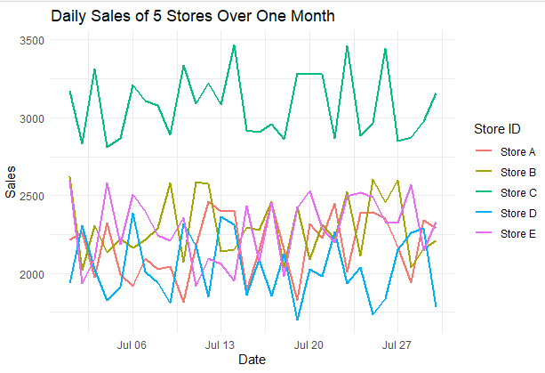

Problem 2 (10 Marks)
Scenario: A sales dashboard shows monthly revenue for the last 3 years as a line chart with Month on
the x-axis (Cartesian coordinates).
a) What does each (x, y) point on this chart represent, in terms of the underlying data?
b) If the analyst wants to emphasize the cyclical (seasonal) nature of monthly sales across years, what coordinate
system change might reveal this pattern better than Cartesian coordinates?
c) What visual advantage would a radial/circular layout provide for spotting a recurring seasonal peak, e.g., every December?

a) What does each (x, y) point on this chart represent, in terms of the underlying data?

Each (x, y) point represents the monthly revenue for a specific month.
- x-axis: Month (time)
- y-axis: Revenue earned in that month

b) If the analyst wants to emphasize the cyclical (seasonal) nature of monthly sales across years, what coordinate system change might reveal this pattern better than Cartesian coordinates?

Use a Polar (Radial/Circular) coordinate system instead of Cartesian coordinates. This arranges the months in a circle, making seasonal patterns easier to observe.

c) What visual advantage would a radial/circular layout provide for spotting a recurring seasonal peak, e.g., every December?
A radial/circular layout places the same month (such as December) at the same position each year. This makes recurring seasonal peaks easy to identify because high values line up at the same angle, clearly highlighting annual patterns.

Conclusion:

